Jenkins Task -03 (Task 1)

Task 1
Create one Jenkins job using the below code and create three stages:
- stage1: Git clone to download the source code.
- stage2: Sonarqube Integration to check the quality of code.
- stage3: Slack Integration to send the alerts to slack.
URL: https://github.com/betawins/VProfile-1.git

Overall Task Title
Jenkins CI Pipeline with Git, SonarQube Code Quality Analysis, and Slack Notifications
Objective
To design and implement a Jenkins job that automates the CI process by:
- Cloning source code from a GitHub repository
- Performing static code analysis using SonarQube to ensure code quality
- Sending real-time build and quality status notifications to a Slack channel
This task demonstrates an end-to-end Continuous Integration workflow.
Prerequisites
- Jenkins server installed and running
- Java (JDK 11/17) installed on Jenkins and SonarQube servers
- Git installed on Jenkins server
- SonarQube server installed and accessible on port 9000
- PostgreSQL database configured for SonarQube
- SonarQube Scanner plugin installed in Jenkins
- SonarQube authentication token generated
- Slack workspace with Jenkins CI app/integration enabled
- Slack Notification plugin installed in Jenkins
- Internet access from Jenkins server
- GitHub repository access
  - Repository URL:
https://github.com/betawins/VProfile-1.git

Stage:1
- stage1: Git clone to download the source code.
Steps Performed
- Opened Jenkins dashboard and clicked New Item.
- Entered the job name V-profile.
- Selected Freestyle project as the job type.
- Clicked OK to create the job.
- Navigated to Source Code Management section.
- Selected Git as the SCM option.
- Entered the Git repository URL:
https://github.com/betawins/VProfile-1.git
- Left Credentials as none (public repository).
- Set Branch Specifier to */master.
- Clicked Save to store the configuration.
- Clicked Build Now to trigger the job.
- Opened Console Output to verify execution.
- Confirmed that Jenkins successfully cloned the repository into the workspace and the build completed with SUCCESS.
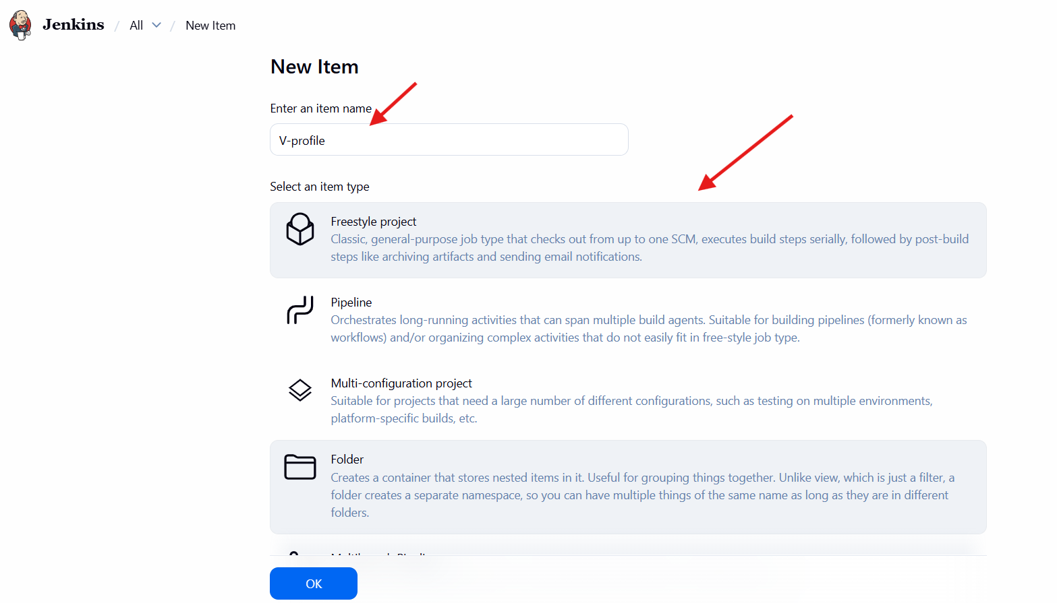
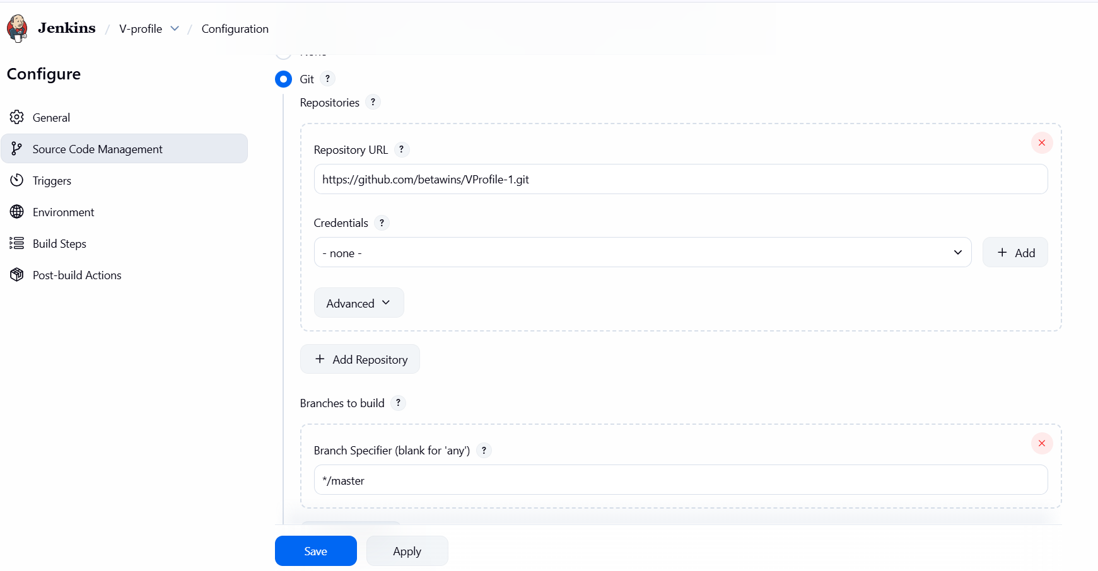
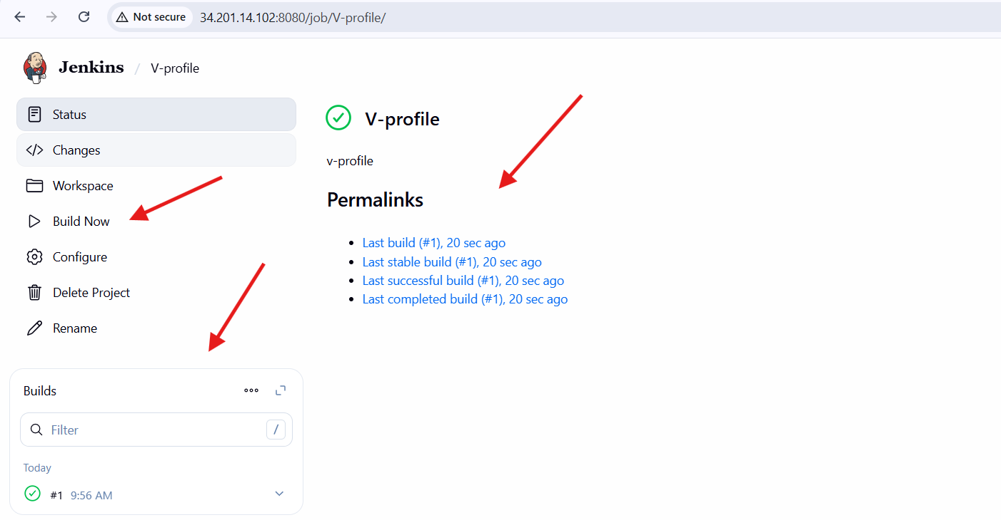
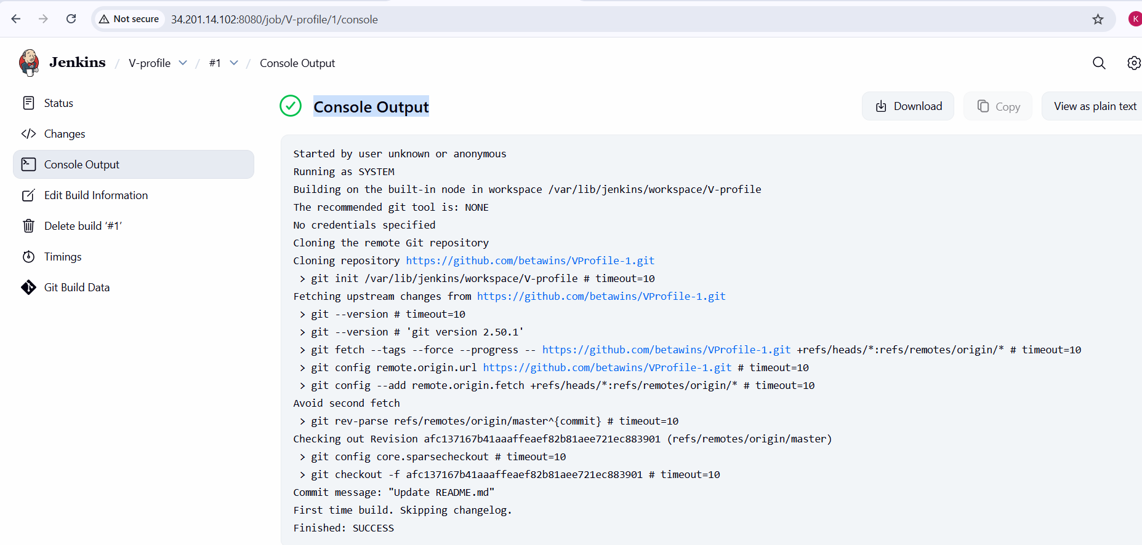

stage2: SonarQube Integration to check the quality of code.
SonarQube Integration (Code Quality Check)
1. Launch EC2 Instance for SonarQube
- Open AWS EC2 → Launch Instance
- Set Instance Name as sonarqube
- Select Amazon Linux 2023 AMI
- Choose instance type (minimum t3.medium / t3.large recommended)
- Configure storage (minimum 20 GB)
- Select or create a Security Group
- Launch the instance
2. Configure Security Group for SonarQube
- Edit inbound rules of the security group
- Add the following rules:
  - SSH → Port 22 → Source 0.0.0.0/0
  - HTTP → Port 80 → Source 0.0.0.0/0
  - Custom TCP → Port 9000 → Source 0.0.0.0/0 (SonarQube UI)
  - PostgreSQL → Port 5432 → Source 0.0.0.0/0 (or restricted to same SG)
- Save rules
3. Connect to EC2 Instance
- SSH into the instance using key pair
- Switch to root user
4. Install Java (Required for SonarQube)
- Update system packages
- Install Amazon Corretto Java 17
- Verify Java installation using java -version
5. Install PostgreSQL Database
- Install PostgreSQL server packages
- Initialize PostgreSQL database
- Enable and start PostgreSQL service
- Verify PostgreSQL service is running
6. Configure PostgreSQL for SonarQube
- Switch to postgres user
- Create database:
  - sonarqube
- Create database user:
  - Username: sonar
  - Password: sonar@123
- Grant all privileges on sonarqube database to sonar
- Set database owner to sonar
- Exit PostgreSQL shell
7. Download and Extract SonarQube
- Navigate to /opt
- Download SonarQube 6.6 zip file
- Unzip the package
- Rename directory from sonarqube-6.6 to sonar
- Verify SonarQube directory structure (bin, conf, data, logs, etc.)
8. Configure SonarQube Database Settings
- Edit file: /opt/sonar/conf/sonar.properties
- Configure PostgreSQL settings:
  - sonar.jdbc.username=sonar
  - sonar.jdbc.password=sonar@123
  - sonar.jdbc.url=jdbc:postgresql://localhost/sonarqube
- Configure web settings:
  - sonar.web.host=0.0.0.0
  - sonar.web.port=9000
- Save and exit configuration file
9. Create Sonar User and Permissions
- Create a dedicated Linux user sonar
- Change ownership of /opt/sonar to sonar user
- Switch to sonar user
10. Start SonarQube Server
- Navigate to /opt/sonar/bin/linux-x86-64
- Start SonarQube using sonar.sh start
- Check status using sonar.sh status
- Verify SonarQube is listening on port 9000
- Check logs under /opt/sonar/logs if needed
11. Access SonarQube Web UI
- Open browser
- Access SonarQube using:
  - http://<EC2-Public-IP>:9000
- Login with default credentials:
  - Username: admin
  - Password: admin
- Change admin password when prompted
12. Create SonarQube Project
- Go to Projects → Create Project
- Choose Create a local project
- Enter:
  - Project Key (e.g., Sabear)
  - Project Name
- Complete project creation
13. Install SonarQube Plugins in Jenkins
- Open Jenkins → Manage Jenkins → Plugins
- Search for:
  - SonarQube Scanner
  - Sonar Quality Gates
- Install required plugins
- Restart Jenkins if required
14. Generate SonarQube Authentication Token
- In SonarQube UI, go to Administrator → Security
- Generate a Global Analysis Token
- Copy the token (shown only once)
15. Add SonarQube Token to Jenkins Credentials
- Open Jenkins → Manage Jenkins → Credentials
- Add new credential:
  - Kind: Secret text
  - Secret: SonarQube token
  - ID: sonar-token
- Save credentials
16. Configure SonarQube Server in Jenkins
- Go to Manage Jenkins → Configure System
- Under SonarQube installations:
  - Name: sonarqube-server
  - Server URL: http://<SonarQube-Public-IP>:9000
  - Authentication token: sonar-token
- Save configuration
17. Configure SonarQube Scanner Tool
- Go to Manage Jenkins → Global Tool Configuration
- Add SonarQube Scanner
- Set name (e.g., sonarqube)
- Enable Install automatically
- Select scanner version
- Save configuration
18. Configure Jenkins Job for SonarQube Analysis
- Open Jenkins job (V-profile)
- Go to Configure
- Add Build Step → Execute SonarQube Scanner
- Add analysis properties:
  - sonar.projectKey
  - sonar.projectName
  - sonar.sources
  - sonar.java.binaries
  - sonar.junit.reportsPath
  - sonar.jacoco.reportPath
- Save job configuration
19. Run Jenkins Job
- Click Build Now
- Monitor Console Output
- Verify SonarQube scanner execution completes successfully
20. Verify Results in SonarQube
- Open SonarQube UI
- Navigate to the project (Sabear)
- Verify:
  - Code analysis completed
  - Metrics displayed (Bugs, Vulnerabilities, Code Smells)
  - Quality Gate status: Passed
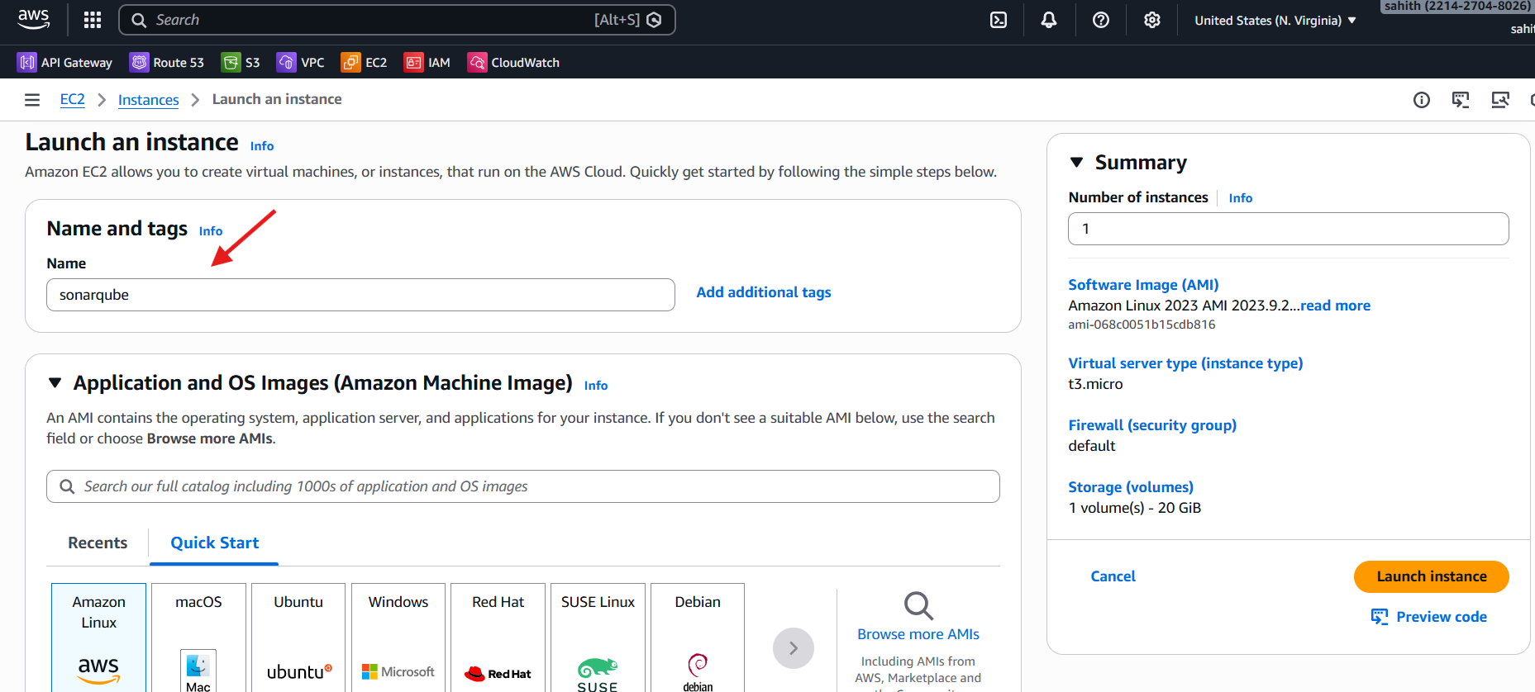
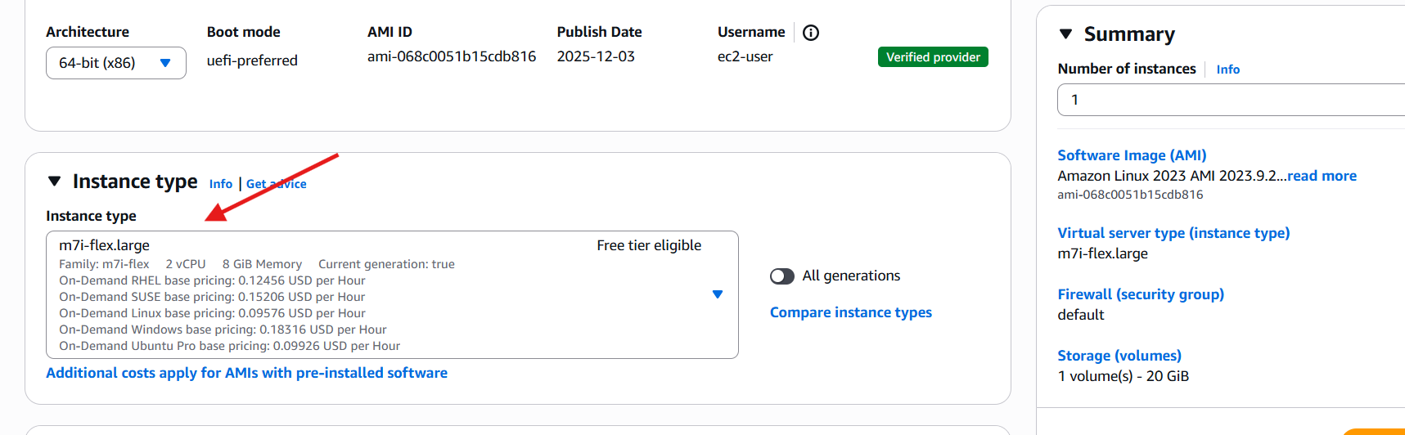

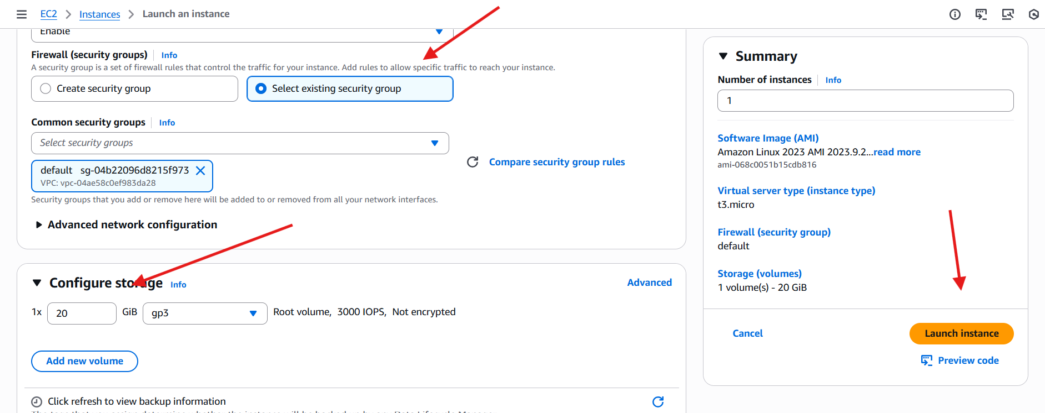

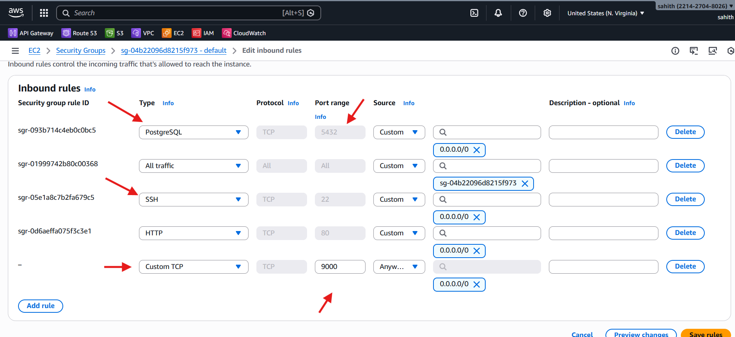
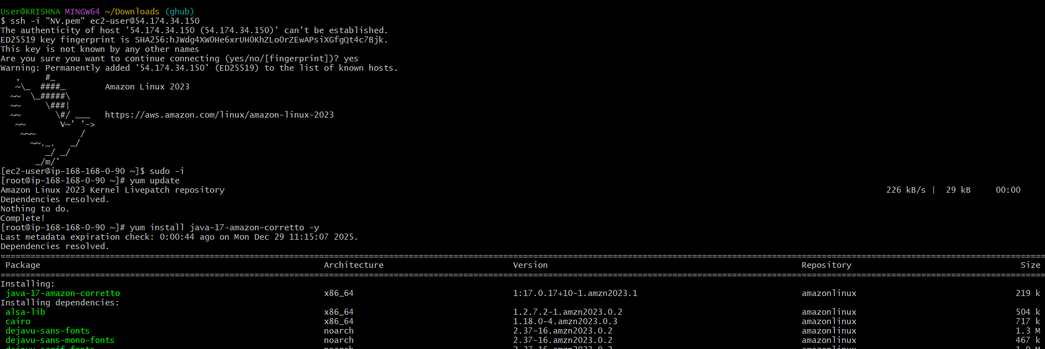
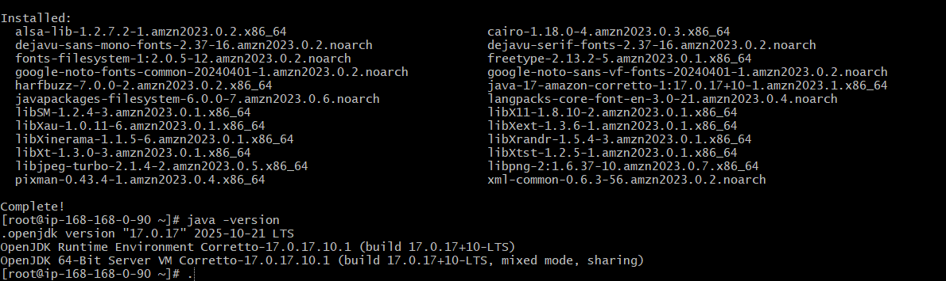
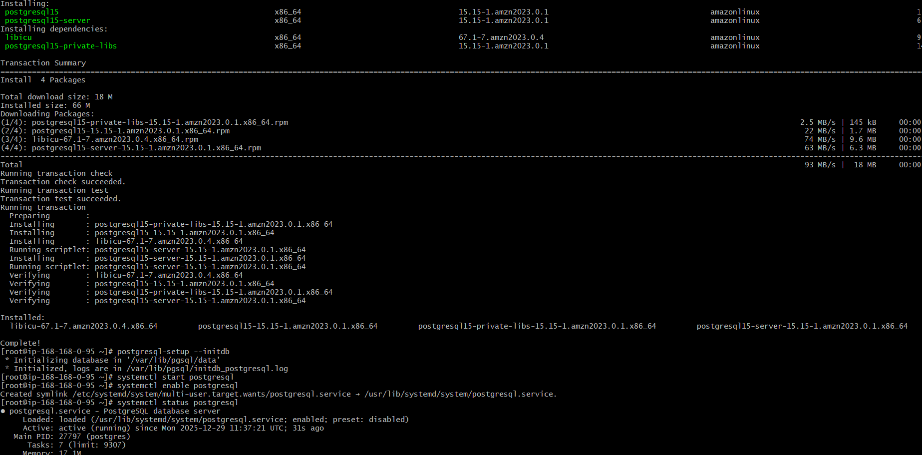
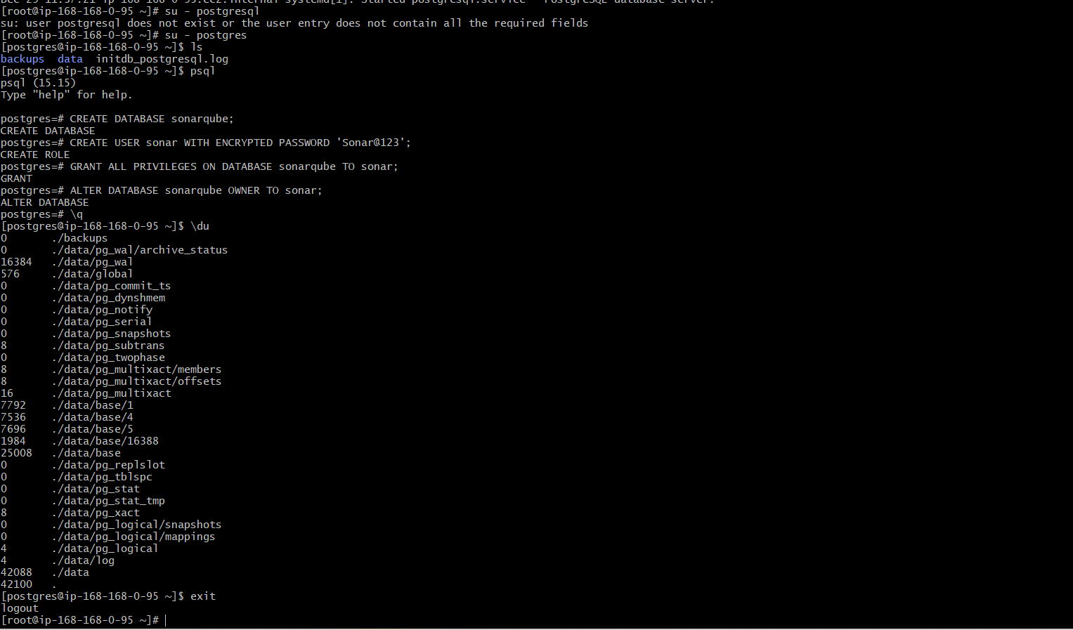
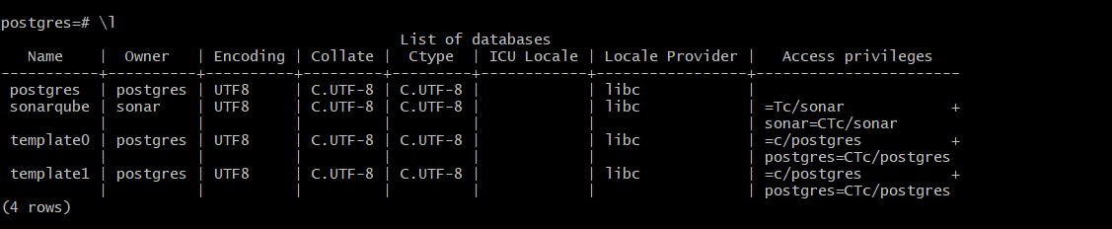
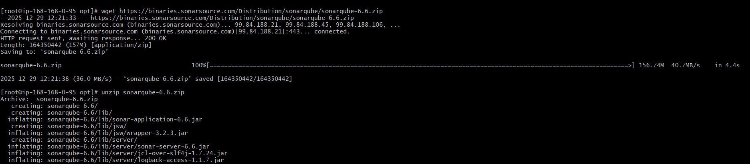
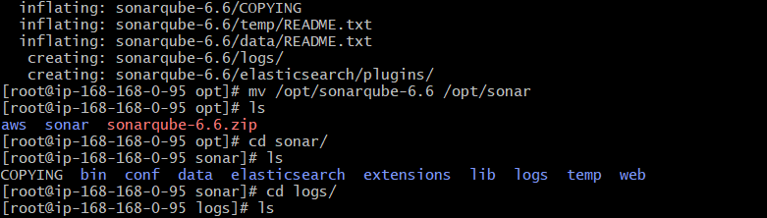
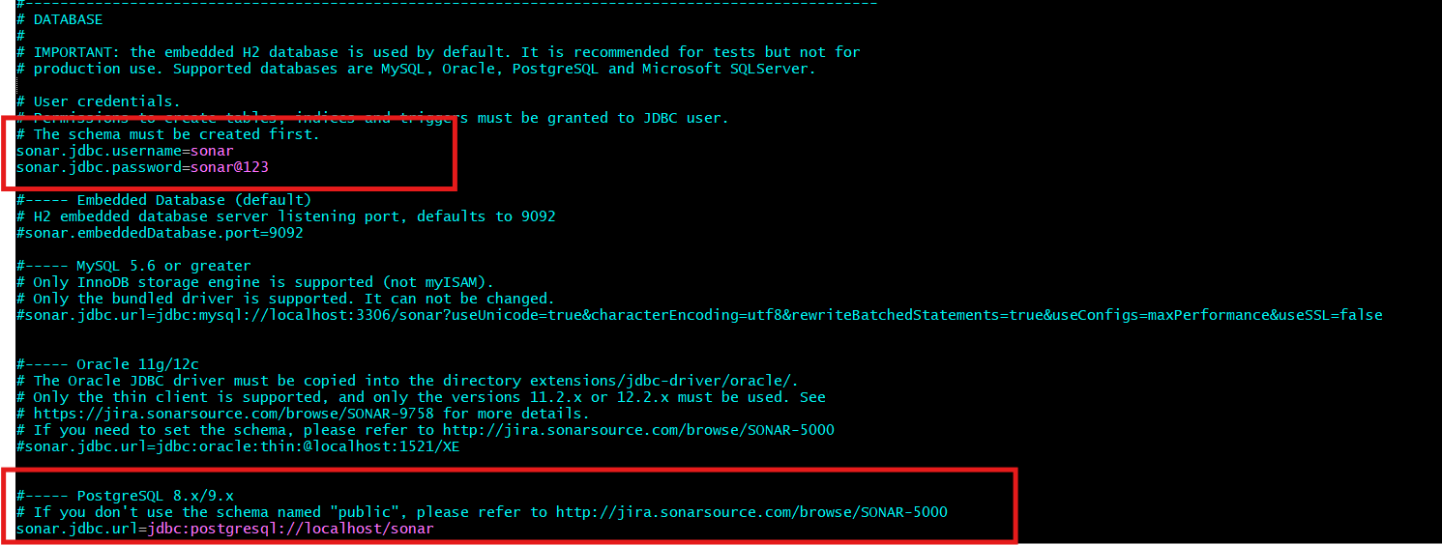
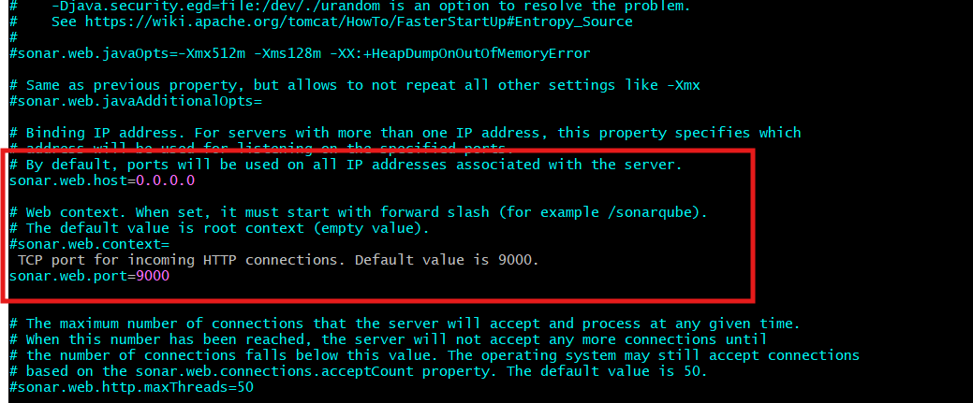
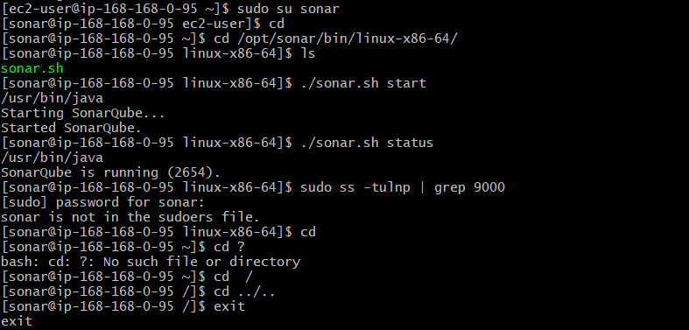

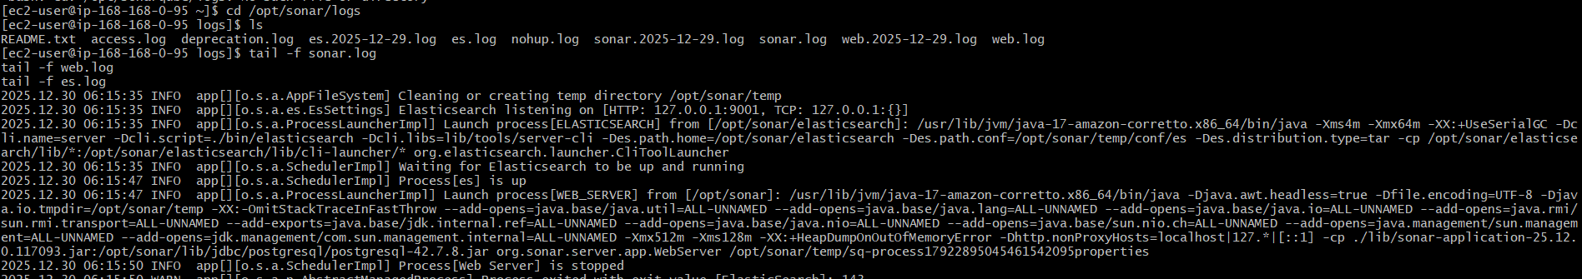
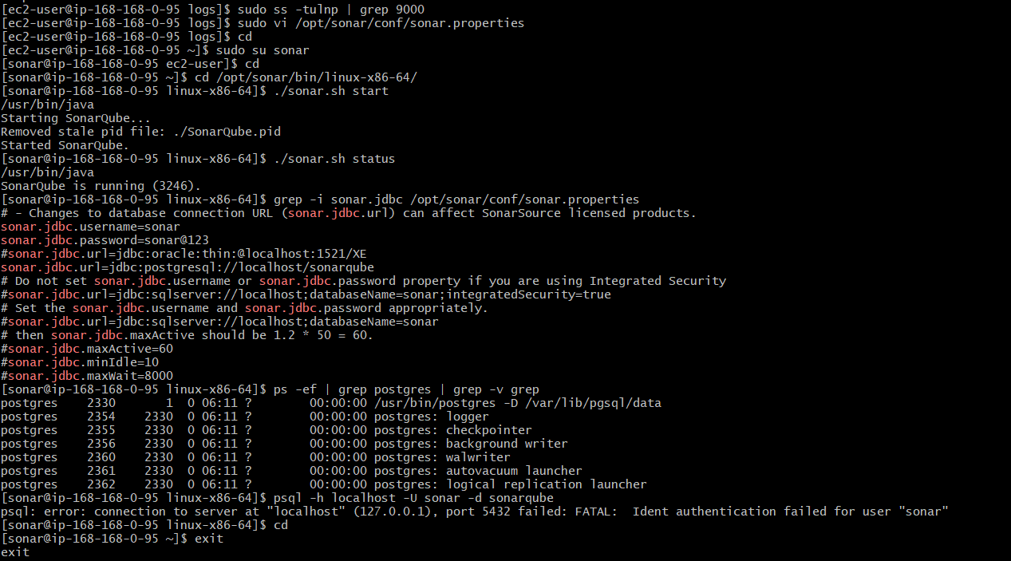
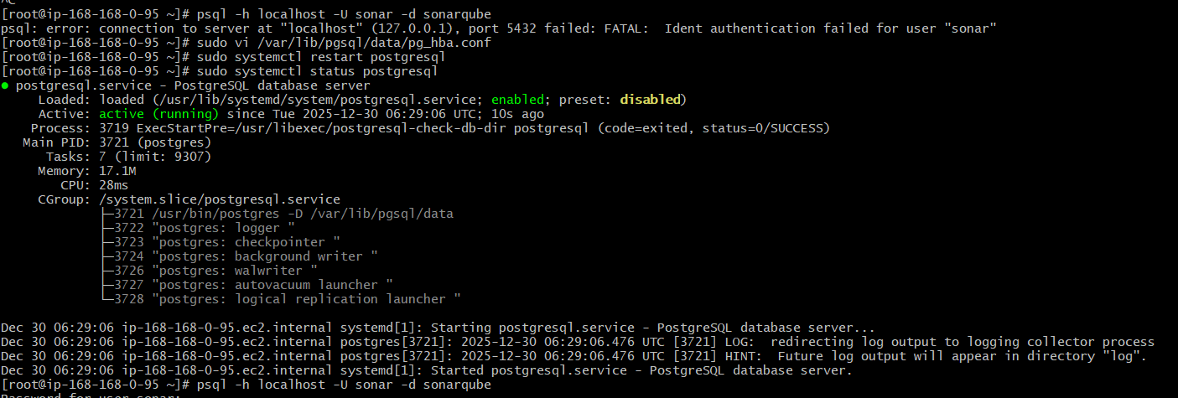
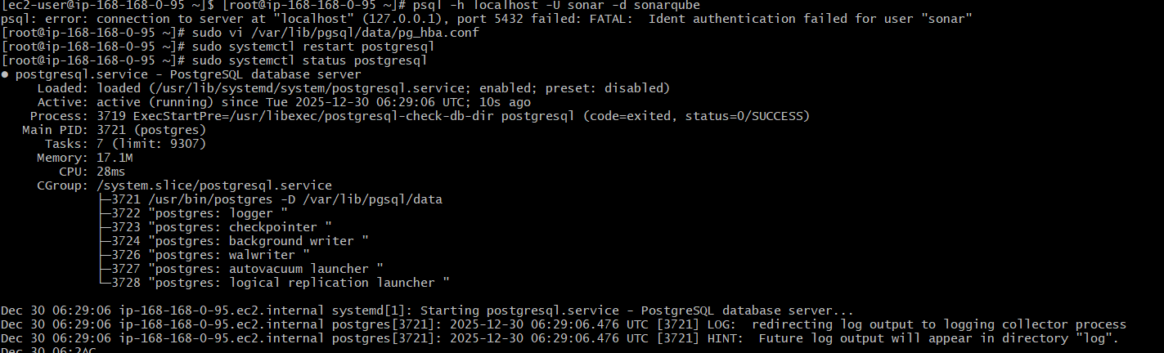
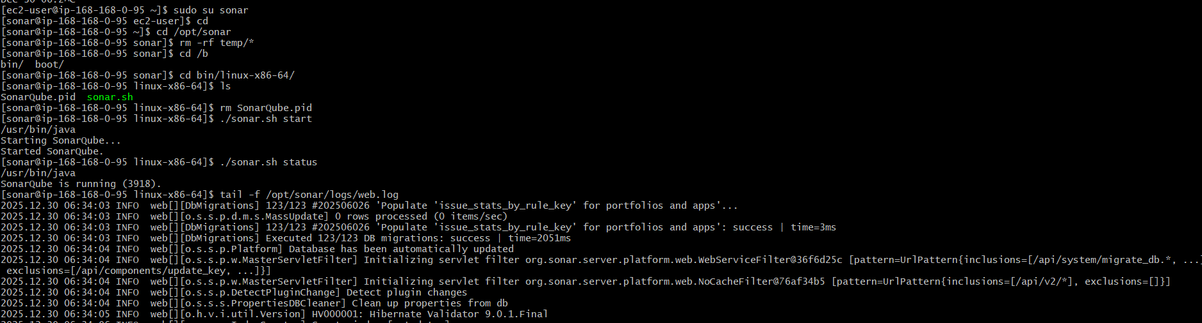
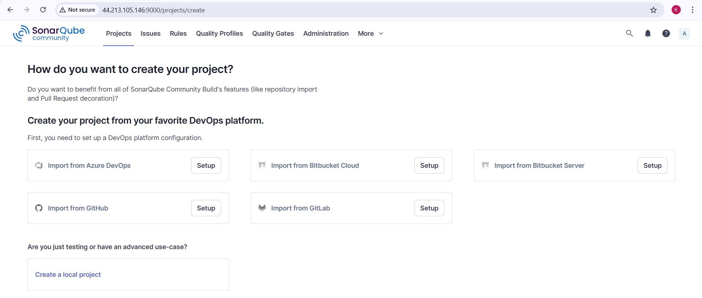
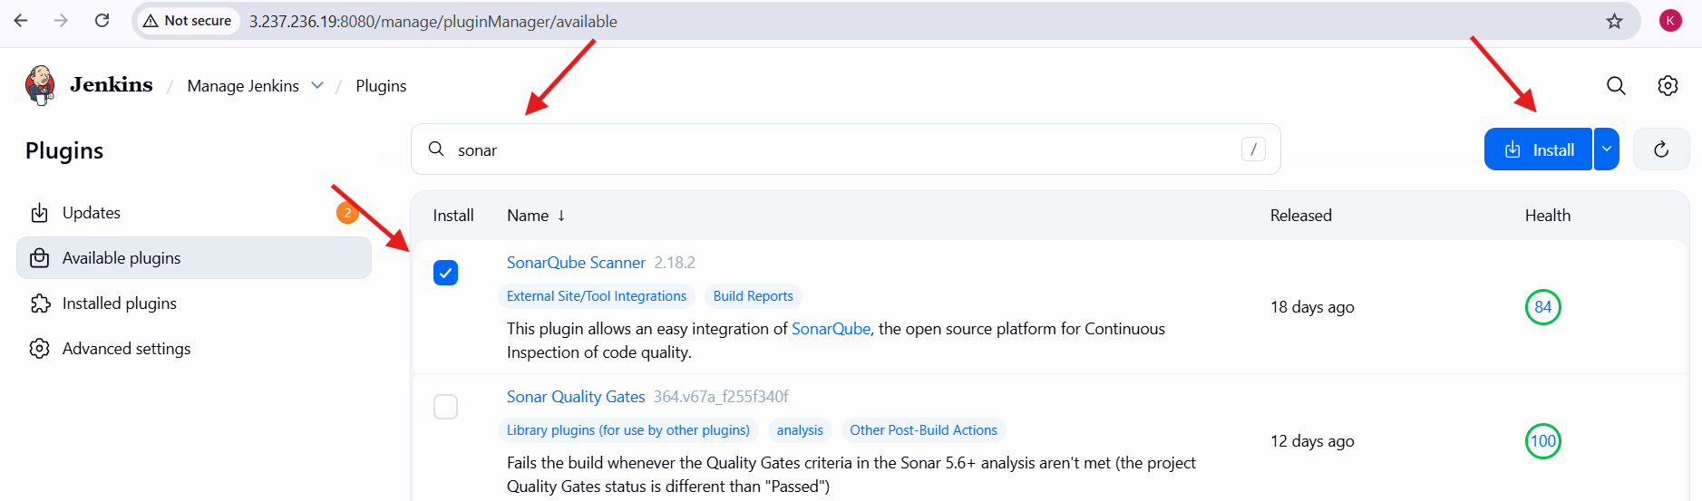
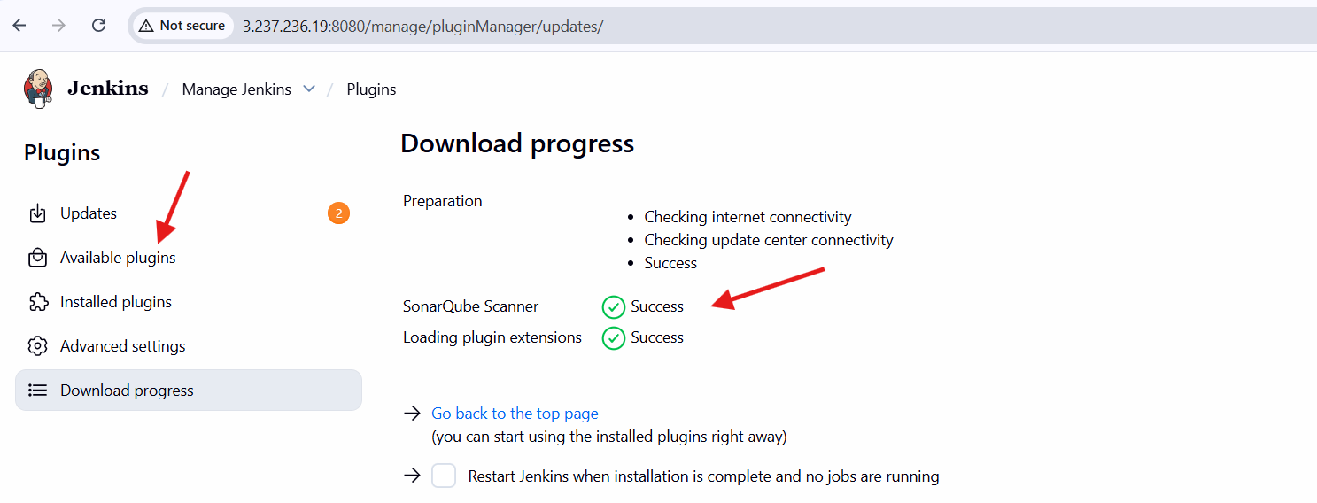
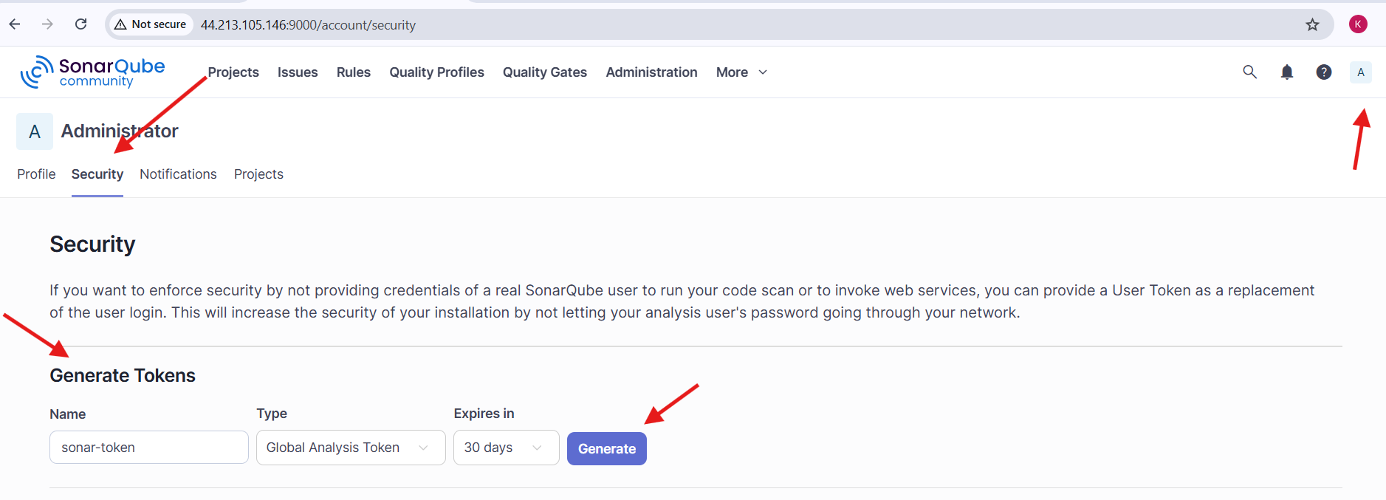
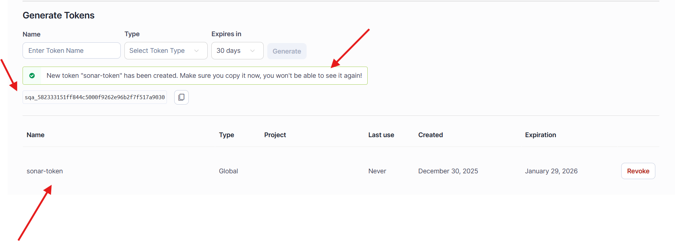
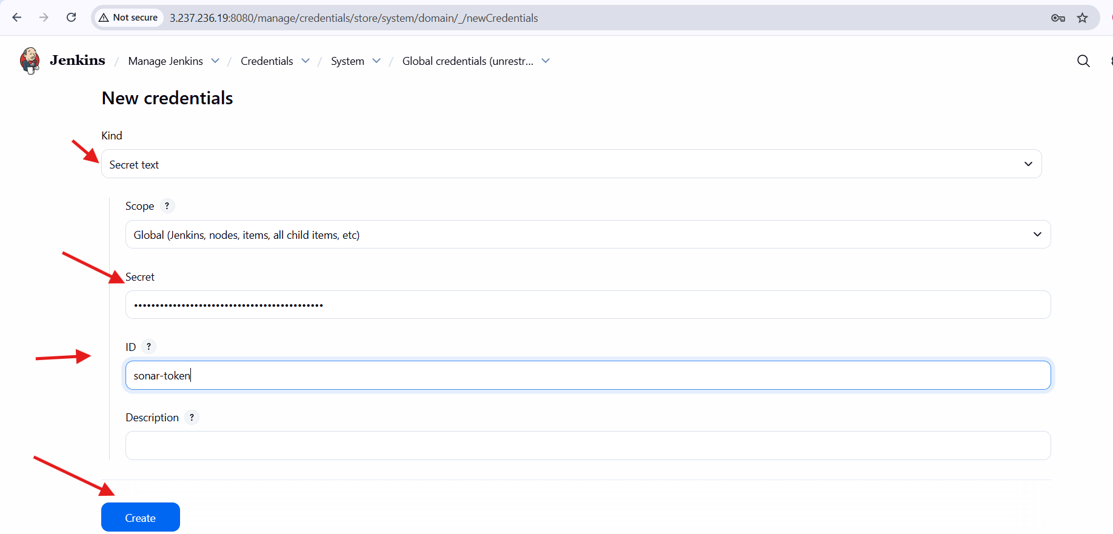
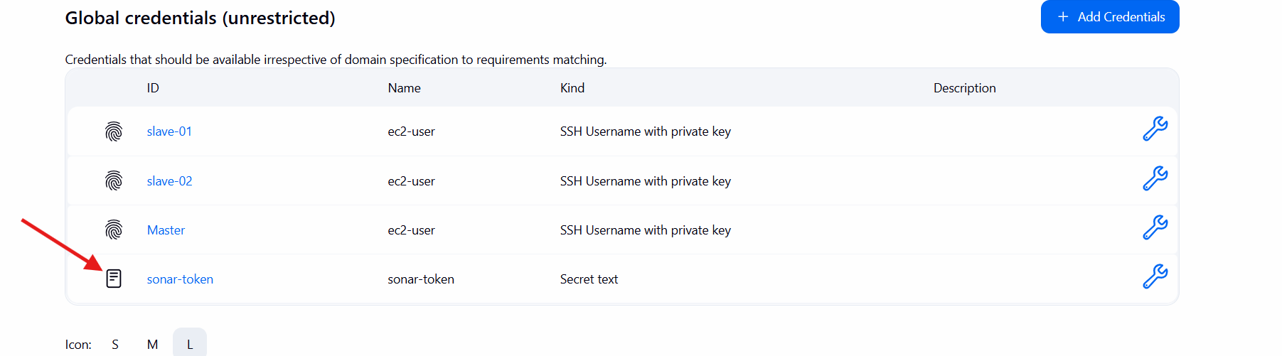
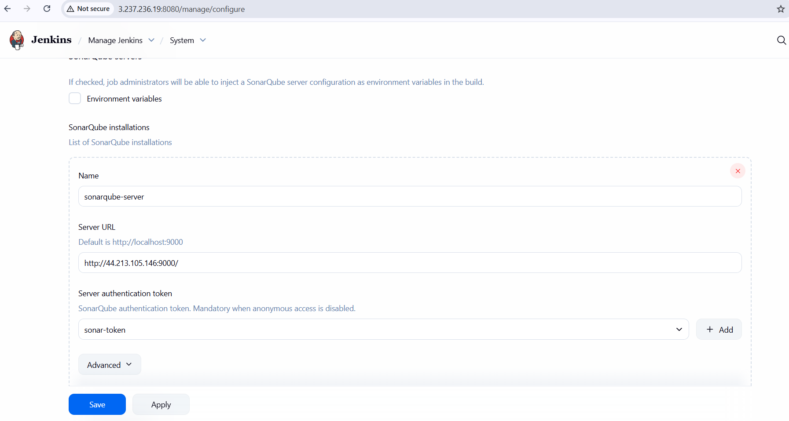
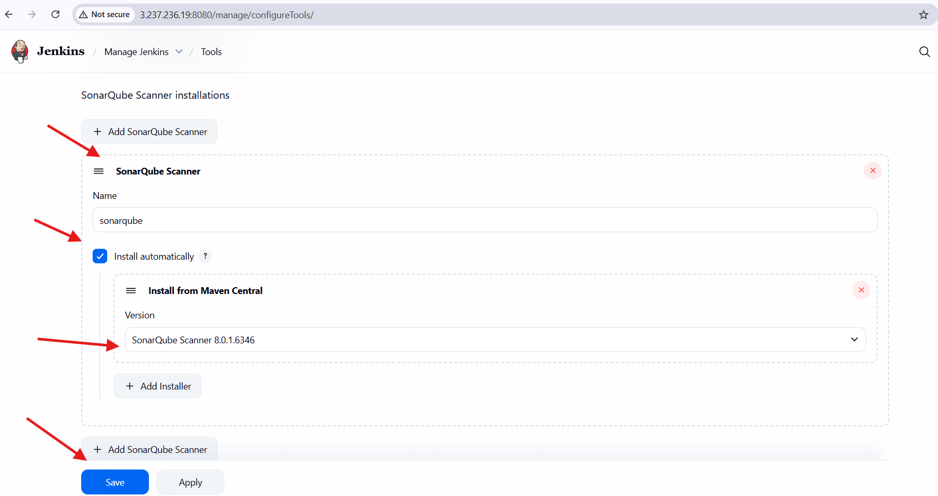
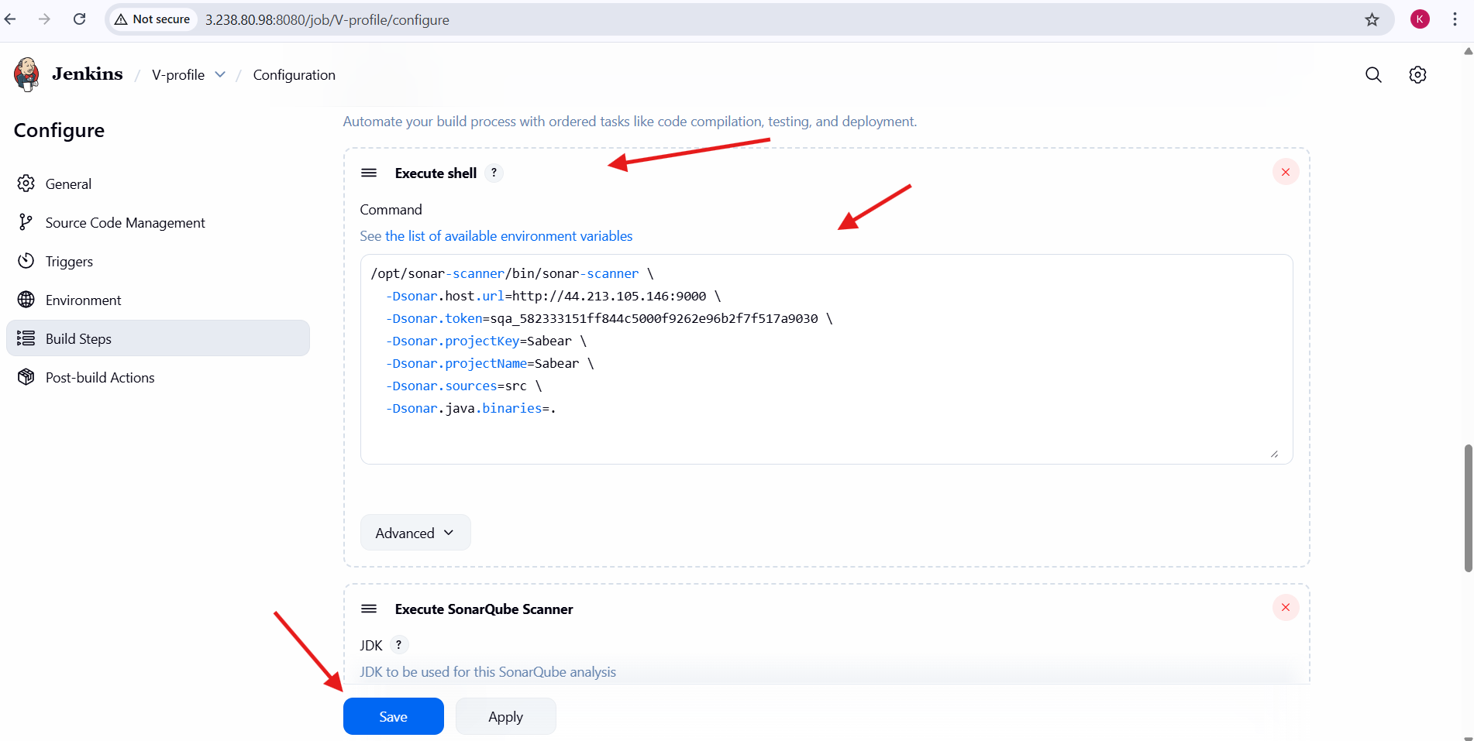
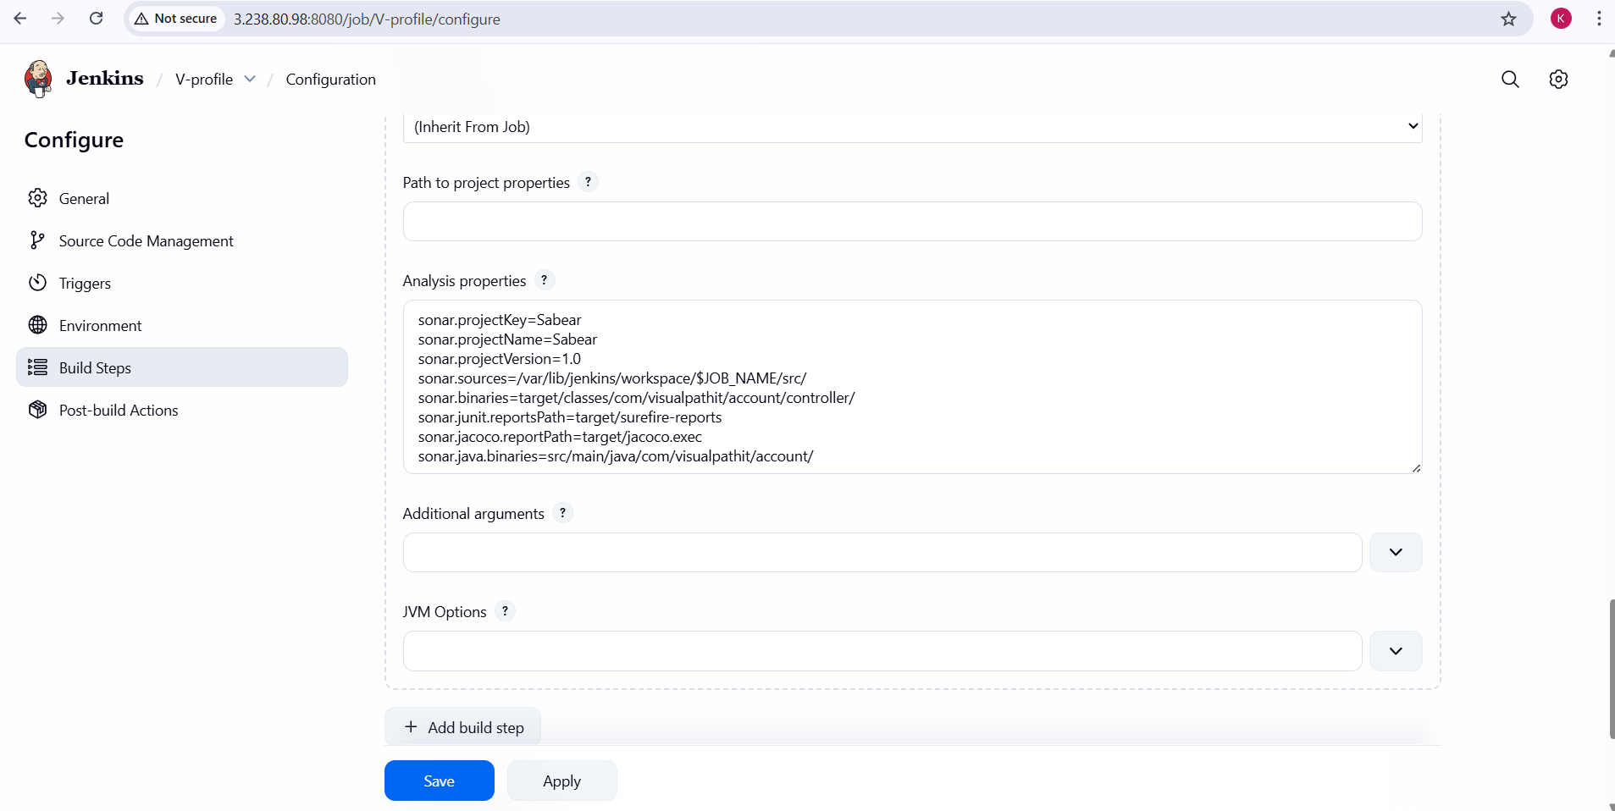
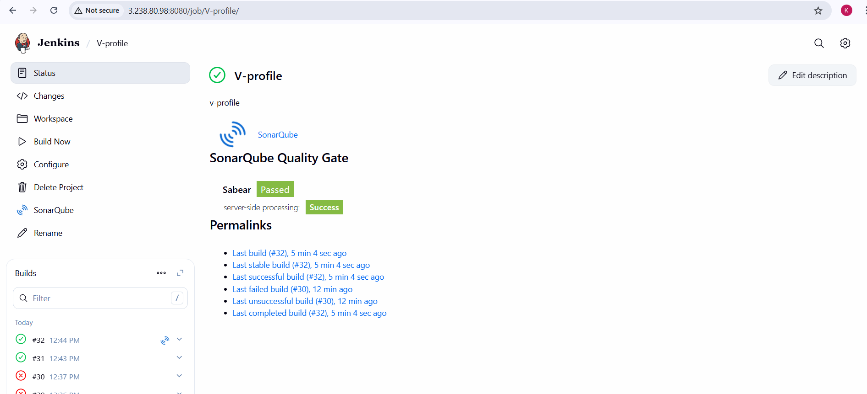
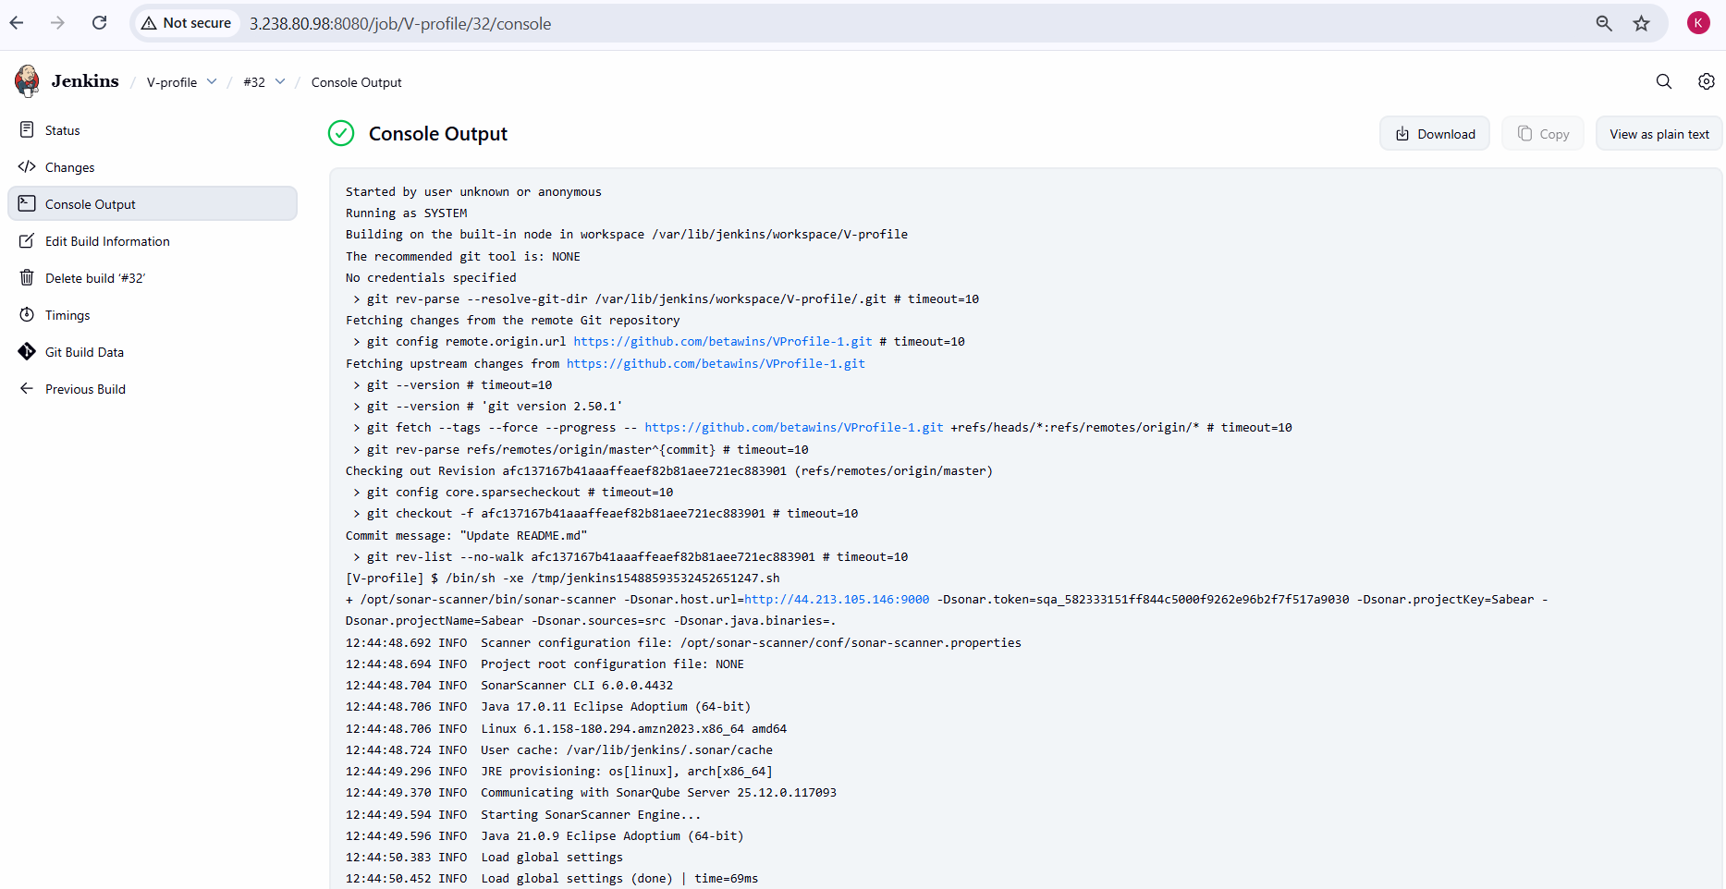
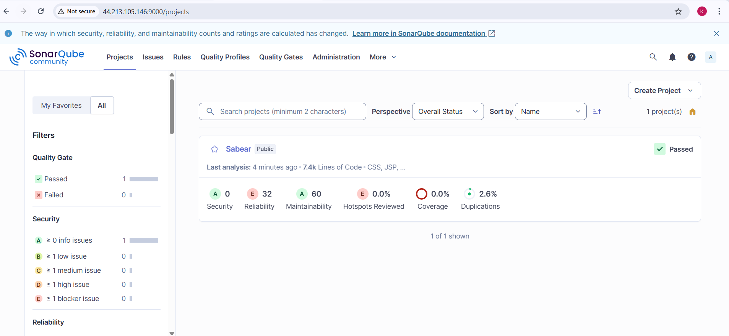

Stage3: Slack Integration to send the alerts to slack.
Step-by-Step Implementation
Step 1: Verify Slack Workspace and Channel
- Logged in to the Slack workspace TechieHorizon
- Identified and used the Slack channel:
  - #jenkins-integration

Step 2: Add Jenkins CI App to Slack
- Opened Slack → Apps
- Searched for Jenkins CI
- Opened the Jenkins CI app
- Clicked Add Jenkins CI Integration
- Selected channel #jenkins-integration
- Successfully added Jenkins CI integration to the channel
Step 3: Generate Slack Integration Token
- Opened Jenkins CI integration configuration page in Slack
- Copied the Integration Token generated by Slack
- Token is used as the authentication key for Jenkins → Slack communication
Step 4: Install Slack Notification Plugin in Jenkins
- Navigated to Jenkins Dashboard
- Opened Manage Jenkins → Manage Plugins
- Searched for Slack Notification
- Installed the Slack Notification Plugin
- Restarted Jenkins if required

Step 5: Add Slack Token to Jenkins Credentials
- Navigated to Manage Jenkins → Credentials
- Added new credentials:
  - Kind: Secret Text
  - Secret: Slack Integration Token (copied from Slack)
  - ID: slack
  - Description: slack
- Saved the credentials successfully
Step 6: Configure Global Slack Settings in Jenkins
- Opened Manage Jenkins → Configure System
- Navigated to Global Slack Notifier Settings
- Configured the following:
  - Team Subdomain: techiehorizon
  - Integration Token Credential ID: slack
  - Channel / Slack ID: #jenkins-integration
  - Enabled Custom Slack App Bot User
- Clicked Test Connection
- Connection verified successfully
- Saved configuration

Step 7: Configure Slack Notifications in Jenkins Job
- Opened Jenkins job V-profile
- Navigated to Configure
- Enabled Slack Notifications in post-build actions
- Configured notifications for:
  - Build Started
  - Build Success
- Saved job configuration
Step 8: Trigger Jenkins Build
- Manually triggered a Jenkins build
- Observed build execution completion

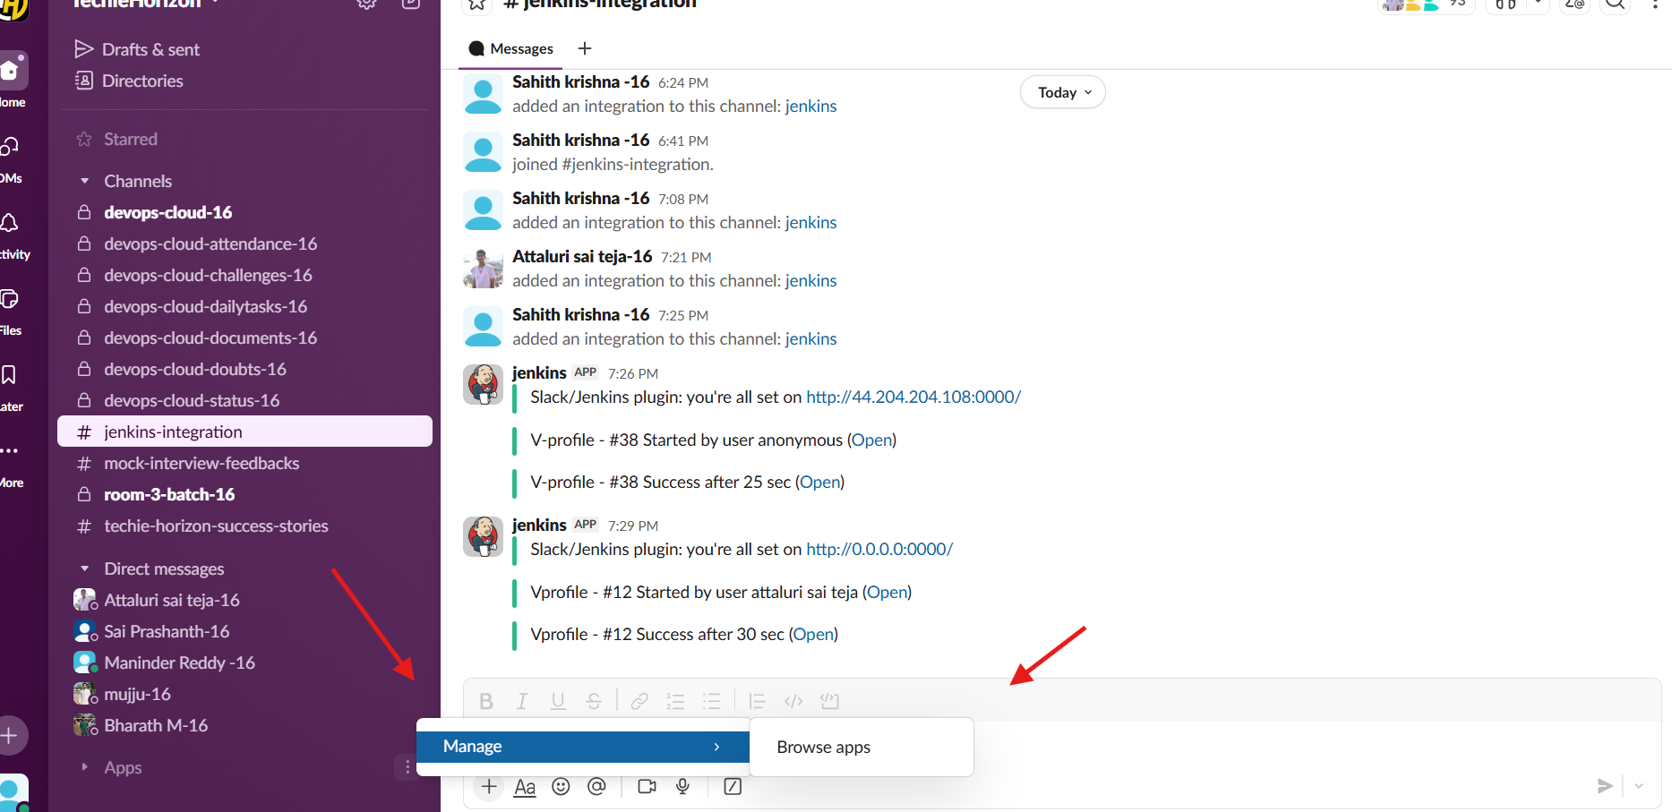
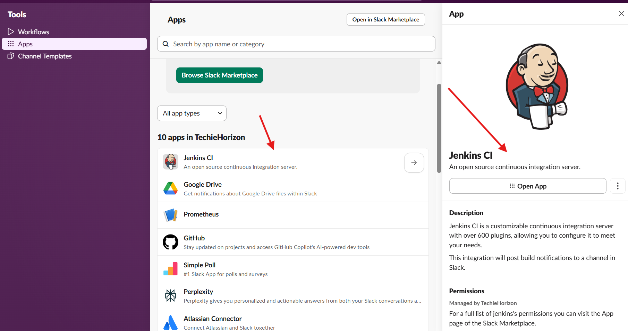
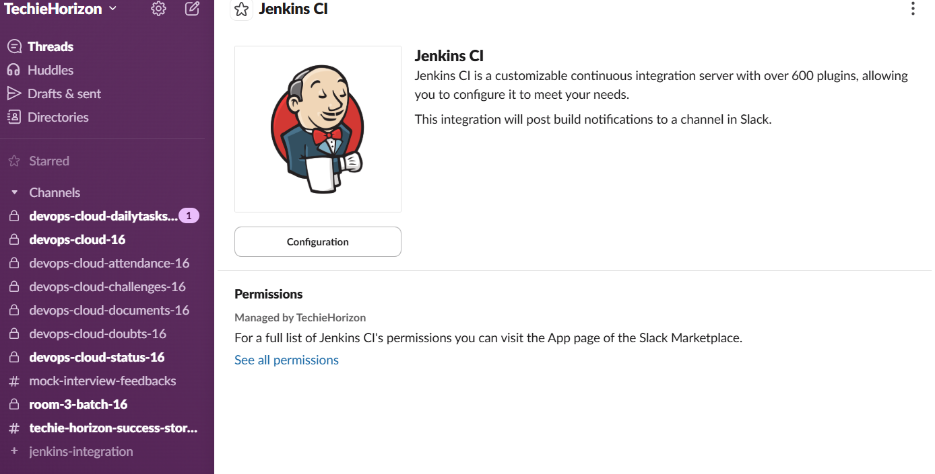
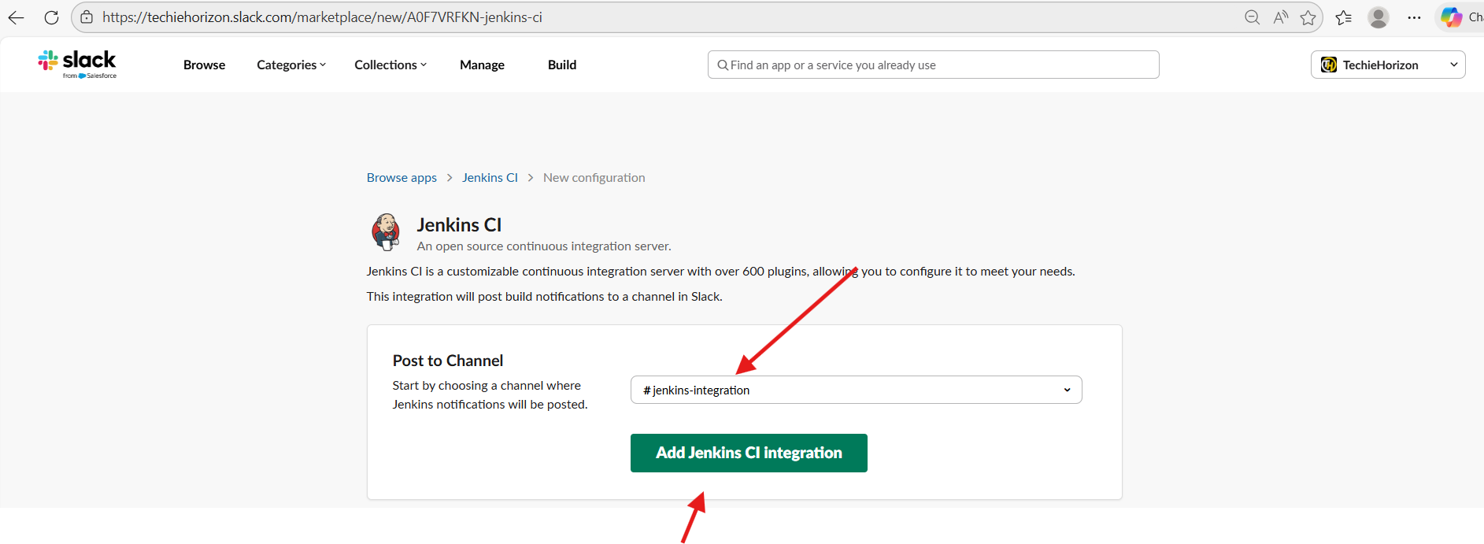
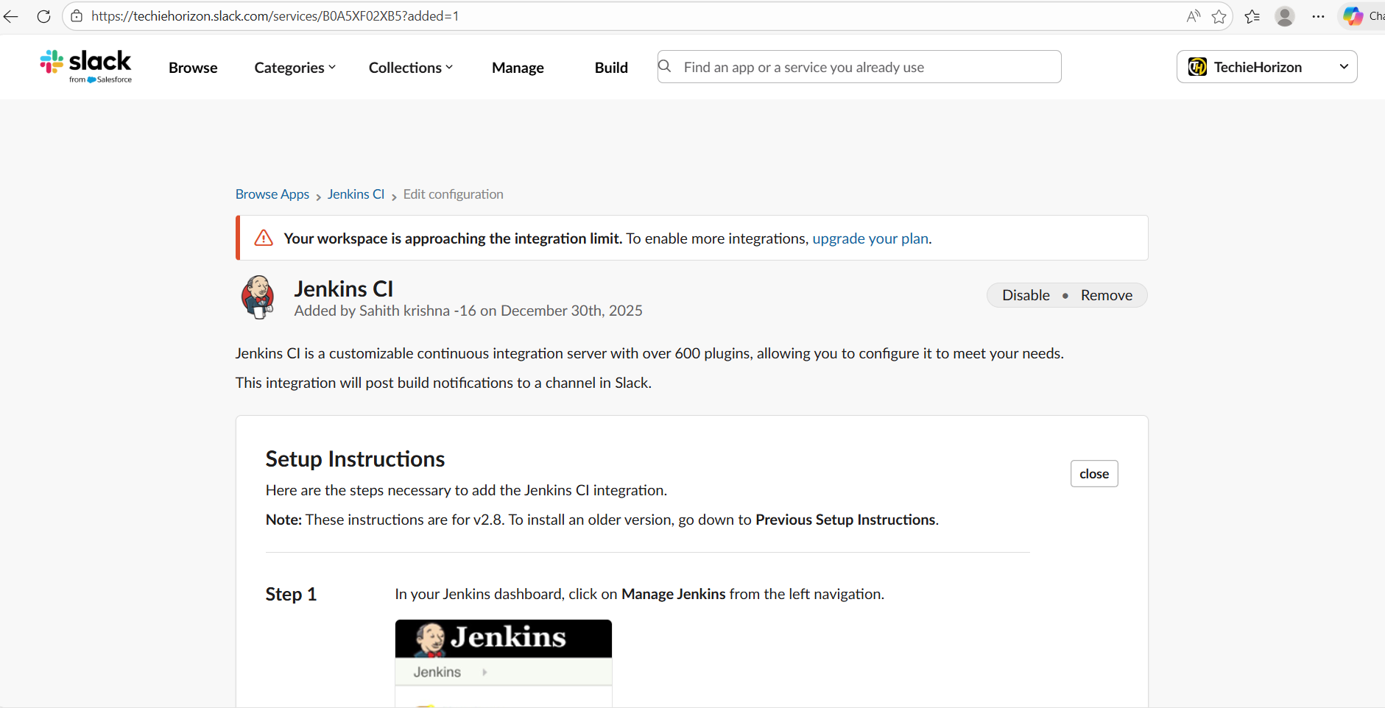

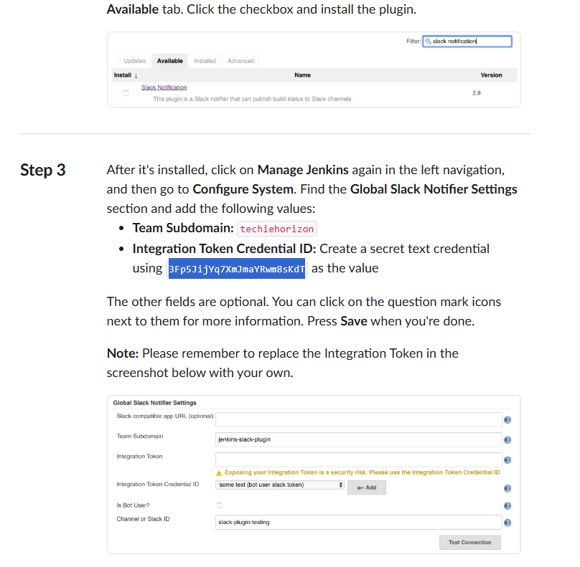

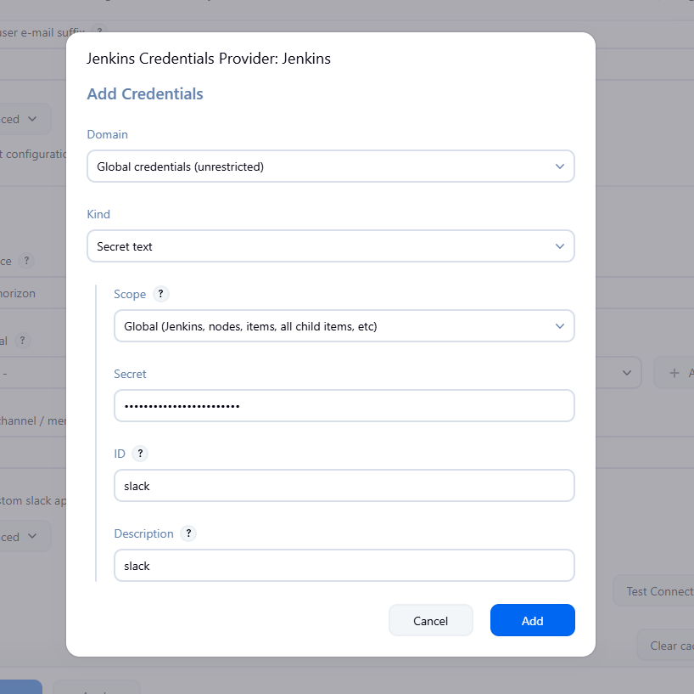
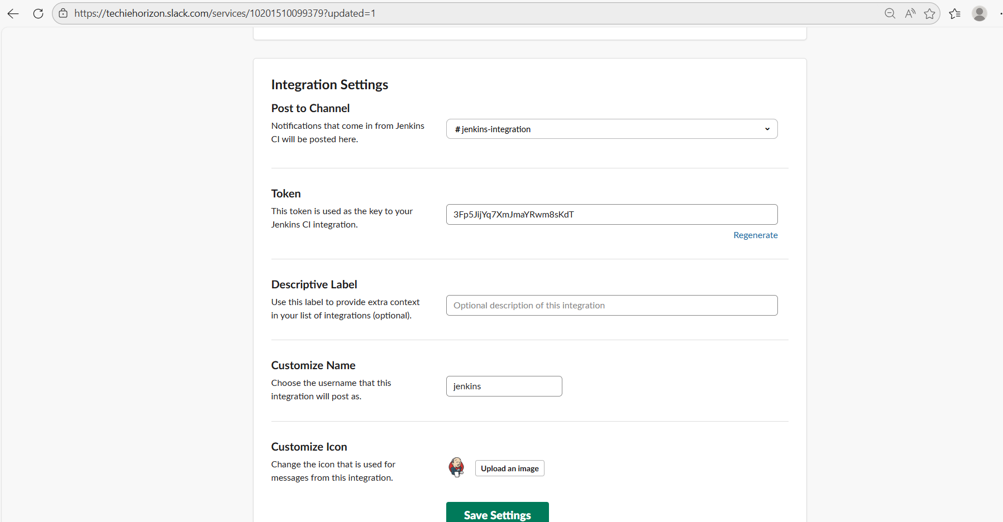
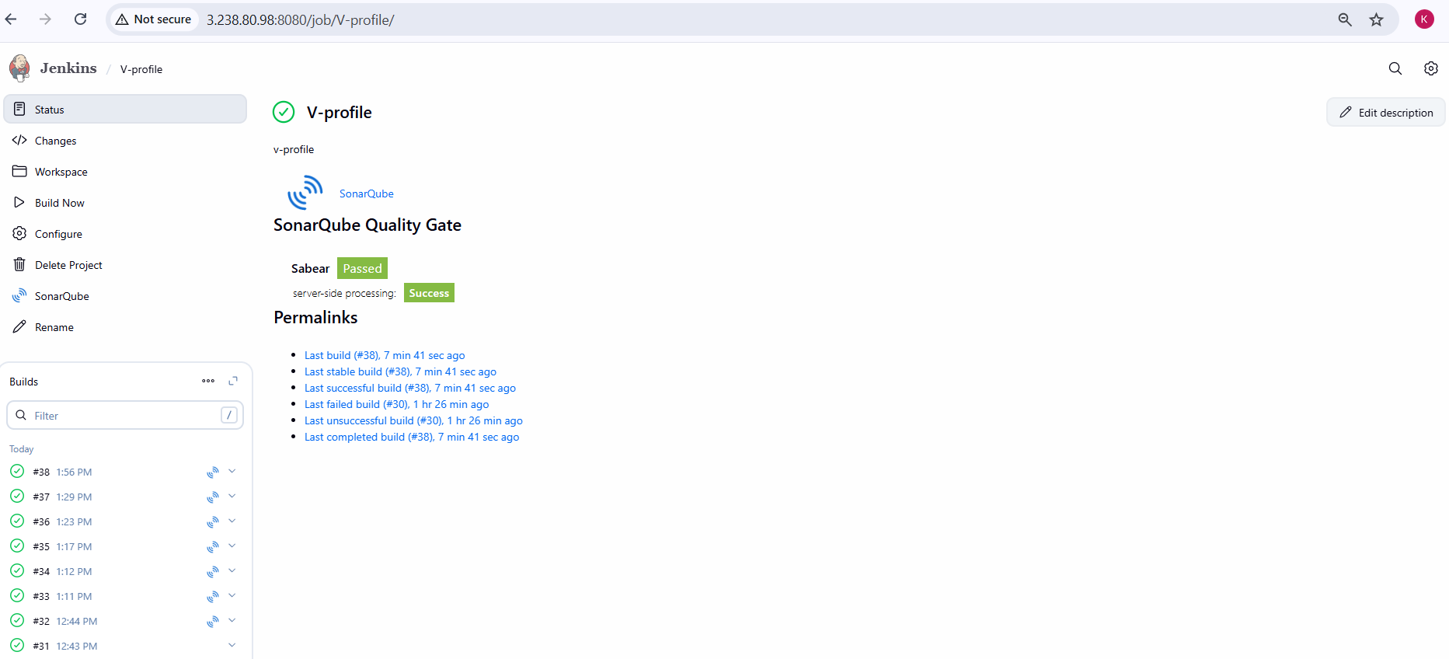
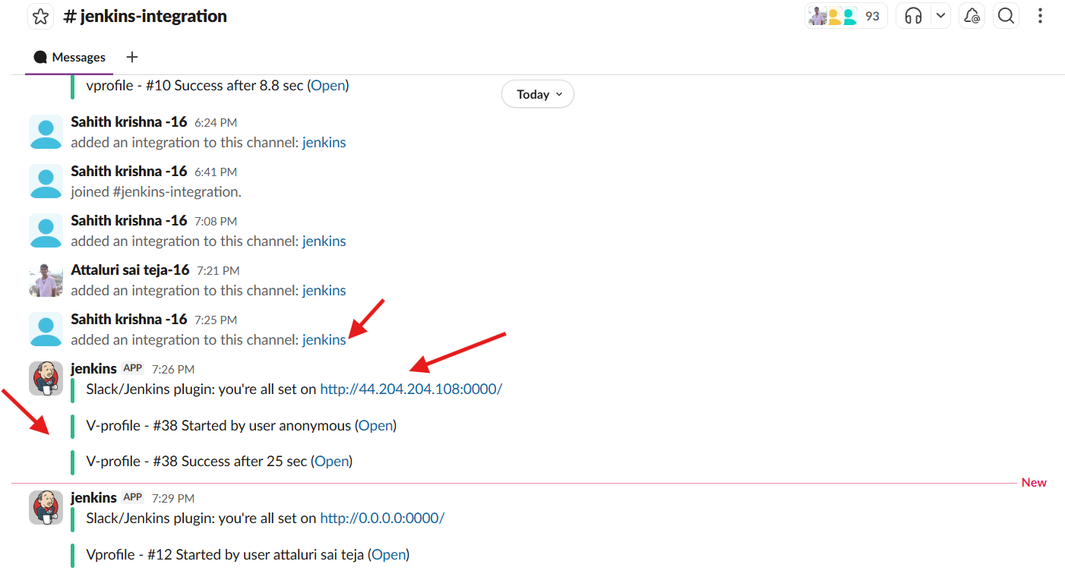

Overall Task Validation steps
- Jenkins job successfully clones the GitHub repository
- SonarQube analysis runs without errors in Jenkins console output
- Project appears in SonarQube dashboard with metrics (Bugs, Vulnerabilities, Code Smells)
- Quality Gate status shows Passed
- Slack channel receives notifications for:
  - Build started
  - Build success/failure
  - SonarQube analysis status
Overall Task Errors Faced
- mvn: command not found
  - Occurred due to Maven not being installed; resolved by using SonarQube Scanner directly
- Could not find 'java' executable in JAVA_HOME or PATH
  - Resolved by correctly configuring JDK path in Jenkins Global Tool Configuration
- SonarQube authentication failures
  - Fixed by generating a new SonarQube token and adding it as a Jenkins secret text credential
- Slack invalid_auth error
  - Resolved by using the correct Slack integration token and workspace subdomain
- PostgreSQL authentication issues
  - Resolved by updating pg_hba.conf and restarting PostgreSQL service
Overall Task Conclusion:
This task successfully implemented a complete Jenkins CI pipeline with:
- Automated source code checkout from GitHub
- Static code quality analysis using SonarQube
- Real-time Slack notifications for build and analysis status
The pipeline improves code reliability, enforces quality gates, and enhances team communication by providing immediate feedback, aligning with CI/CD best practices.

